Arkansas River Basin Water Forum
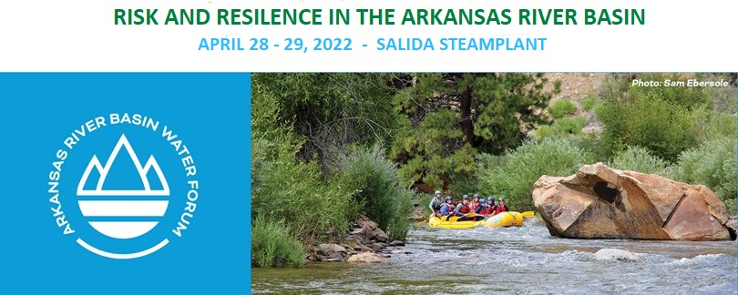
Sponsorship Program

CONTACT
Jean Van Pelt
Program Manager
ARBWF1994@gmail.com
ARBWF.ORG

Sponsorship Opportunities

Support water education in the Arkansas River Basin.

The Arkansas River Basin Water Forum is the premier water education event in the Arkansas River Basin. Entering its 27th year, the Forum brings together diverse water interests and users and offers a platform for education and earnest dialogue on water resource issues and needs. Nearly 200 people representing agricultural, municipal, industrial, environmental, recreational, and governmental interests attend the annual Forum, as well as interested citizens and others from outside the Basin. Your sponsorship helps to underwrite the costs associated with the conference and underscores the importance of this indispensable resource through educational opportunities now and into the future.

Watershed Sponsor $5000
- 4 registrations to the 2-day Water Forum.
- First-position logo display online/in e- newsletters.
- An opportunity to speak to the entire audience about your organization before or after a break.
- Listing on website and other publicity.
- Option to add brochures and premiums to ARBWF attendees gift bag.

Headwaters Sponsor $2500
- 3 registration tickets to the 2-day Water Forum.
- Prominent display of sponsor recognition at the Water Forum.
- Listing on website and other publicity.
- Option to add brochures and premiums to ARBWF attendees gift bag.

Additional Sponsorships
Aquifer Sponsor $1000
- 2 registrations to the 2-day Water Forum.
- Sponsor recognition at the Water Forum
- Listing on website and other publicity.

Reservoir Sponsor $500
- 1 registration to the 2-day Water Forum.
- Listing on website and other publicity.

Name badge sponsor $3,000 (Only one available)
Scholarship sponsor $1,000 (Sponsor travel expenses for 3 recipients to attend the Forum)
Break sponsor $600 (Special signage at breaks and in Forum program)
The Arkansas River Basin Water Forum is a 501(C)3 non-profit organization which serves as a conduit for information about the Arkansas River Basin in Colorado. The objective of the Arkansas River Basin Water Forum is to promote open dialogue among water users and the general public. Through this dialogue, the ARBWF seeks to create a greater understanding of the Arkansas River Basin, Colorado water law, water conservation, and the many uses and value of water.

Sponsor online
www.ARBWF.org

Please indicate your sponsorship level:

$5000 Watershed Sponsor
$2500 Headwaters Sponsor
$1000 Aquifer Sponsor
$500 Reservoir Sponsor
Other

ARBWF Scholarship Fund
I would also like to donate to the Scholarship fund in the amount of $________________

I have enclosed my sponsorship check in the amount of $

OR
Please bill my Visa/Master Card/Discover/AMEX in the amount of $

Company Name Account # V-code (on the back)
Signature Expiration date
City, State, Zip Phone Email
Please email your logo for publicity to: arbwf1994@gmail.com

REQUIRED: Names of attendees, please use additional paper if needed.

___________________________________________________________________________________________________

Please mail completed form and payment to:
ARBWF
ARBWF1994@gmail.com
PO Box 11295, Pueblo CO 81001

